## R1

Q: What is the differnce between a host and an end system? List several different types of end systems. Is a Web server an end system?

A:

Host: Sender og modtager pakker baseret på IP, så Hosts og end systems er det samme.

End systems: Client (Computer, Laptop, smartphone, etc...), Web server, mail server, etc...

Web server er et End system.

## R19

Suppose Host A wants to send a large file to Host B. The path from Host A to Host

B has three links, of rates R1 = 500 kbps, R2 = 2 Mbps, and R3 = 1 Mbps.

a. Assuming no other traffic in the network, what is the throughput for the

file transfer?

b. Suppose the file is 4 million bytes. Dividing the file size by the throughput,

roughly how long will it take to transfer the file to Host B?

c. Repeat (a) and (b), but now with R2 reduced to 100 kbps.

a) Det er den midste af R1, R2 og R3, hvilket er R1 (500 kbps)

b) 32000000 bits / 500000 bps = 64 sek

c) Nu er R2 bottlenecken og derfor den mindste værdi.

32000000 bits / 100000 bps = 320 sek

## R23

What are the five layers in the Internet protocol stack? What are the principal

responsibilities of each of these layers?

(Se 1.5.1 for detalgeret beskrivelse af hvert lag)

5. Application (Beskeder, HTTP osv., Står for overførslen af beskeder mellem hosts)

4. Transport (Står for at transportere applications-beskeder mellem hosts)

3. Network (Står for at flytte netværks-pakker mellem hosts)

2. Data Link (Står for at flytte pakker mellem routere/hosts)

1. Physical (Fysisk transport af bits)

## R24

What do encapsulation and de-encapsulation mean? Why are they needed in

a layered protocol stack?

At "encapsulate" er det at gå et lag ned i 5 lags modellen, hvor man efter hvert lag kommer en header på dataen der passer til det lag.

Der er også den mulighed at en pakke kan blive brugdt op i mindre pakker, hvis den er for stor, alle disse mindre pakker får hver

headers, sådan at de også kan finde frem til ende distinationen.

"De-encapsulate" er så den modsatte process for den som modtager pakkerne, hvor man starter nede fra i de 5 lag og arbejder sig opad.

Her bliver lagene fjerne som man kommer længere op, her bliver det pågældende lags header fjernet og "payloadet", altså det andet data sendt

op til det næste lag.

Det smarte ved det, er at hvert lag kan arbejde uafhængigt af de andre, så man har meget flexibilitet når man vil tilføje funktioner.

Facit svar:

Encapsulation is the process of passing a packet from a higher layer to a lower layer.

In the simplest case, it simply appends additional information (i.e., a header) to the

source packet. In more complicated scenarios, the original packet can be split into

multiple packets, each carrying its own header. Decapsulation is the opposite process

of encapsulation. It extracts the header from a source packet from a lower layer and

passes the payload to the higher layer. If lower layer packets are part of a sequence,

the corresponding payloads are put together before they are passed to the higher

layer. Each protocol in a layer of a protocol stack relies on the services of the lower

layers but not on their information. Thus, the information a protocol needs to process

a packet should entirely be contained in the header of that protocol. Encapsulation

and decapsulation are flexible mechanisms to allow each protocol to operate

independently from others while being able to interface with each other.

## Netopgave – 1

<http://gaia.cs.umass.edu/kurose_ross/interactive/end-end-delay.php>

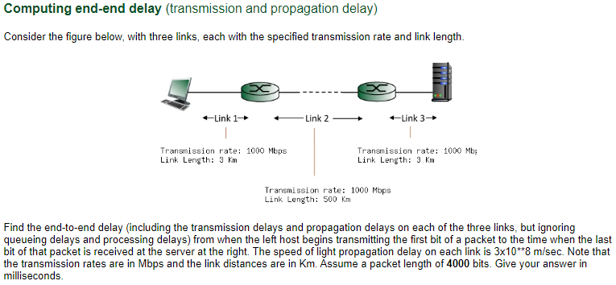

Link 1:

* Transmission time: 4000 bits / 1000 Mbps = 0.004000 msec.
* Propagation time: 3 Km / 3x10^8 m/sec = 0.010000 msec.

Link 2:

* Transmission time: 4000 bits / 1000 Mbps = 0.004000 msec.
* Propagation time: 500 Km / 3x10^8 m/sec = 1.666667 msec.

Link 3:

* Transmission time: 4000 bits / 1000 Mbps = 0.004000 msec.
* Propagation time: 3 Km / 3x10^8 m/sec = 0.010000 msec.

Sum = 1.698667 msecs.

## Netopgave – 2

<http://gaia.cs.umass.edu/kurose_ross/interactive/end-end-throughput.php>

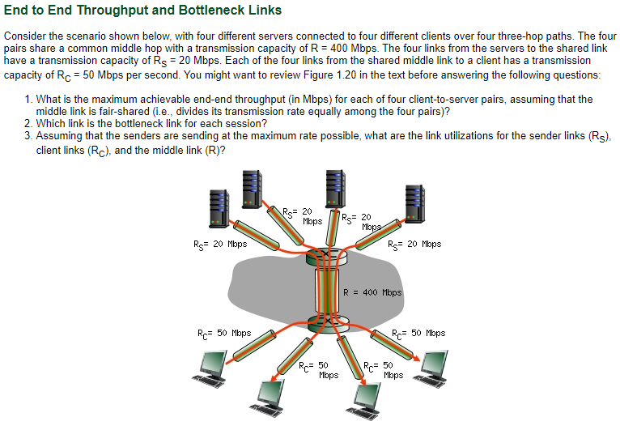

1. Det afhænger af den mindste af Rs, R og Rc, som i dette tilfælde er Rs som er 20 Mbps
2. Rs som har den laveste transmission capacity
3. Rs er 100% procent da den er bottlenecken, R er 100 (R capacitet) / 20 (Rs capacitet, og max) = 20%, Rc er 50 (Rc capacitet) / 20 (Rs capacitet, og max) = 40%

## Problem 6 (P6)

This elementary problem begins to explore propagation delay and transmission

delay, two central concepts in data networking. Consider two hosts, A

and B, connected by a single link of rate *R* bps. Suppose that the two hosts

are separated by *m* meters, and suppose the propagation speed along the link

is *s* meters/sec. Host A is to send a packet of size *L* bits to Host B.

a. Express the propagation delay, *d*prop, in terms of *m* and *s*.

b. Determine the transmission time of the packet, *d*trans, in terms of *L* and *R*.

c. Ignoring processing and queuing delays, obtain an expression for the endto-

end delay.

d. Suppose Host A begins to transmit the packet at time *t* = 0. At time *t* =

*d*trans, where is the last bit of the packet?

e. Suppose *d*prop is greater than *d*trans. At time *t* = *d*trans, where is the first

bit of the packet?

f. Suppose *d*prop is less than *d*trans. At time *t* = *d*trans, where is the first bit of

the packet?

g. Suppose *s* = 2.5 # 108, *L* = 120 bits, and *R* = 56 kbps. Find the distance

*m* so that *d*prop equals *d*trans.

1. Propagation delay: m / s = sekunder
2. Transmission delay: L / R = sekunder
3. End to end delay: (m / s + L / R) = sekunder
4. Bitten har lige forladt host A
5. Den første bit har ikke nået sin destination endnu, og er stadig i ”røret”
6. Den er nået frem til Host B
7. m= L / R * s, 120 / 56 * 2.5 * 10^8 = 536 Km.

## Mulig eksamensopgave

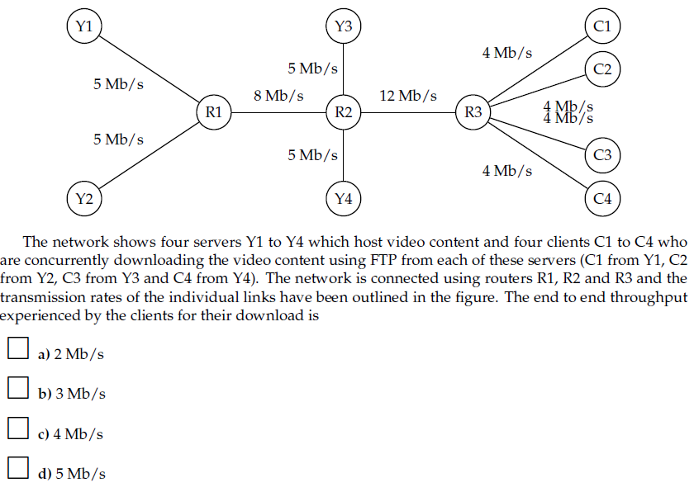

De mødes alle 4 i R3, så det er 12 / 4, som er 3 Mb/s

## Problem 25 (P25)

Suppose two hosts, A and B, are separated by 20,000 kilometers and are connected

by a direct link of *R* = 2 Mbps. Suppose the propagation speed over

the link is 2.5 * 10^8 meters/sec.

a. Calculate the bandwidth-delay product, *R* * *d*prop.

b. Consider sending a file of 800,000 bits from Host A to Host B. Suppose

the file is sent continuously as one large message. What is the maximum

number of bits that will be in the link at any given time?

c. Provide an interpretation of the bandwidth-delay product.

d. What is the width (in meters) of a bit in the link? Is it longer than a

football field?

e. Derive a general expression for the width of a bit in terms of the propagation

speed *s,* the transmission rate *R,* and the length of the link *m*.

1. 2 Mbps (2 mill) * (20.000.000 m / 2.5 * 10^8 meters/sec) = 160000 bits
2. Da nogle vil ankomme før alle er afsted, så vil de ikke være der på samme tid:  
   Transmission delay: L / R: 800.000 bits / 2.000.000 bits = 0,4 sekunder  
   Propagation delay: d / s: 20.000.000 m / 2.5 * 10^8 meters/sec = 0,08 sekunder  
   Hvis man dividere de to tal, så kan man se hvor stor en del af alle bits der er der på samme tid:  
   0,4 / 0,08 = 5; så det vil sige at 1/5 af alle bits vil være der på samme tid: 800.000 / 5 =160000 bits
3. Det beskriver det maksimale antal bits der kan være i linket af gangen.
4. Det kan regnes ud sådan her: d / bandwidth-delay product: 20.000.000 / 160.000 = 125 meter, så det er længere end en normal fodboldbane
5. s/R

## Text opgave

Et streaming firma skal have uploadet et ny datasæt på 40 terabytes til en server, der er placeret tæt hos forbrugerne, men et stykke væk fra firmaet. Deres Internet forbindelse til serveren tillader en gennemsnitlig upload hastighed på 100 Mbps.   Hvor lang tid tager det? Sammenlig tid og pris med at sende en fysisk pakke med et speditionsfirma med næste-dags levering. Antag firmaet køber en dedikeret forbindelse til serveren, med 10 gange højere kapacitet. Hvor lang tid tager det så? Hvad bliver den gennemsnitlige udnyttelsesgrad af denne, under antagelse af at et nyt datasæt uploades en gang om måneden, og den daglige trafik (email, web-surfing, etc) udgør 20 Mbps i gennemsnit. Overvej de praktiske konsekvenser i scenariet.

320.000.000.000.000 bits / 100.000.000 bps = 8.000.000 sekunder, som er 37 dage. Så det er nok hurtigere med levering.

320.000.000.000.000 bits / 1.000.000.000 bps = 320.000 sekunder, som er tager cirka 3,7 dage

Udnyttelsesgrad: 3.7 dage med 100% + 30 dage med 20Mbps/1Gbps / 30dage) = 4.3/30% = 14%

Det er meget billigere at få det shippet og clippet til xqc LUL

# Praktiske øvelser

## Problem 18 (P18)

Perform a Traceroute between source and destination on the same continent

at three different hours of the day.

a. Find the average and standard deviation of the round-trip delays at each of

the three hours.

b. Find the number of routers in the path at each of the three hours. Did the

paths change during any of the hours?

c. Try to identify the number of ISP networks that the Traceroute packets

pass through from source to destination. Routers with similar names and/

or similar IP addresses should be considered as part of the same ISP. In

your experiments, do the largest delays occur at the peering interfaces

between adjacent ISPs?

d. Repeat the above for a source and destination on different continents.

Compare the intra-continent and inter-continent results.

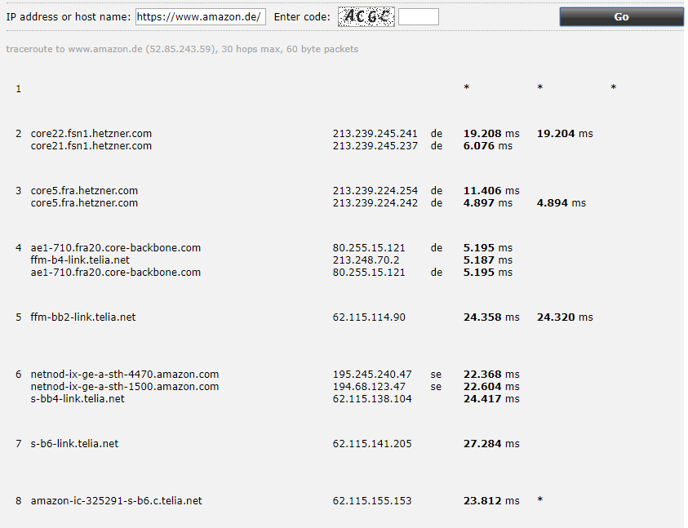

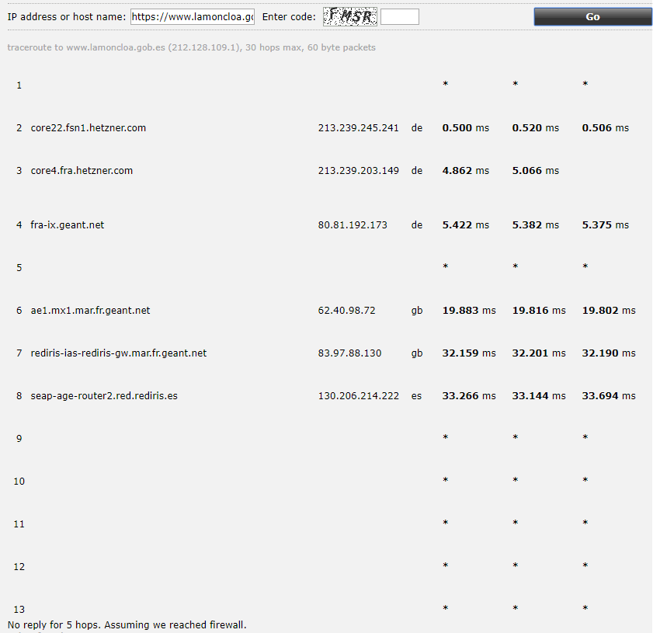  
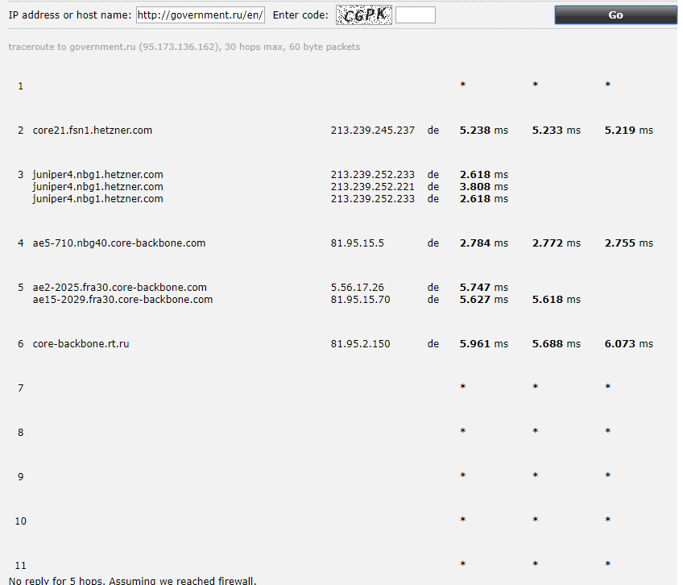

## Wireshark lab (Side 105)